H.H. The Amir of Kuwait International Shooting Grand Prix.

The Arab Shooting Championship.

Kuwait Shooting Federation

The Kuwait Shooting Federation has the pleasure to host H.H The Amir of Kuwait International Shooting Grand Prix and The Arab Shooting Championship, to be held in Kuwait, from the 16th to the 26th of March, 2012.

2012
IT SECTION
Kuwait Shooting Federation
Last Update 12/03/2012


General Information
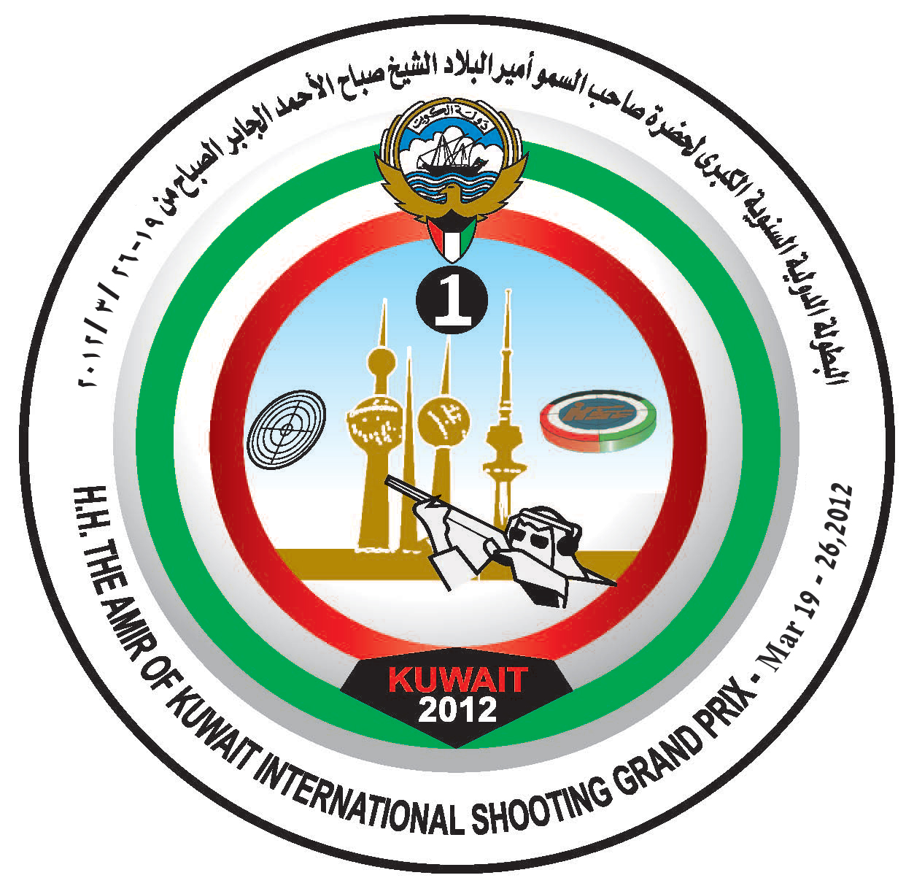

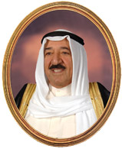

تحت رعاية

حضرة صاحب السمو أمير البلاد
الشيخ صباح الأحمد الجابر الصباح حفظه الله و رعاه

General Information

H.H. Sheikh/ Sabah Al-Ahmad Al-Jaber Al-Sabah Shooting ranges complex is located in Sulaibiya area between 30 – 45 minutes from Kuwait city.

Events

No. | Events | Men | Women
1. | 50 m Rifle 3 Positions | 3 x 40 shots | 3 x 20 shots
2. | 50 m Rifle Prone | 60 shots | 60 shots
3. | 10m Air Rifle | 60 shots | 40 shots
4. | 10 m Air Pistol | 60 shots | 40 shots
5. | 50 m Pistol | 60 shots | - NO
6. | Trap | 125 targets | 75 targets
7. | Double Trap | 150 targets | - NO
8. | Skeet | 125 targets | 75 targets

Shooting Ranges:

5-1. 10m Range (Indoor) : 60 lanes of Suis Ascor.
5-2. 50m Range : 60 lanes of Suis Ascor
5-3. Final Hall (10m &50 m) : 10 lanes of Suis Ascor
5-4. Clay Target Range (Including Final Range) : 6 fields

Entry Process:

Each Federation entering the competition must submit the necessary forms (Annexes 1 - 9) and submit them before the following deadlines. All forms are available on the ISSF Entry System (Federation access only).
Send to | Deadline | Description | Forms
Organizing Committee | 15th Jan 2012 | Preliminary Entry Form | Annex 1
Organizing Committee | 15th Jan 2012 | Preliminary Hotel Form | Annex 2
Organizing Committee | 19th Feb 2012 | Final Entry Form Athletes | Annex 3A
Organizing Committee | 19th Feb 2012 | Final Entry Form Officials | Annex 3B
Organizing Committee | 19th Feb 2012 | Final Travel Form | Annex 4
Organizing Committee | 19th Feb 2012 | Final Hotel Reservation Form | Annex 5
Organizing Committee | 19th Feb 2012 | Final Hotel Rooming List | Annex 6
Organizing Committee | 19th Jan 2012 | Visa Support Form | Annex 7
Organizing Committee | 19th Jan 2012 | Firearms and and Ammunition | Annex 8
Organizing Committee | 19th Jan 2012 | Media Accreditation | Annex 9

Technical Meeting:

The Technical Meeting(s) will take place as follows:

Tuesday, 20th March 2012
Time: 11:00 Hrs.
Location: Final Hall Range

Equipment Control

Equipment control will be open to competitors as scheduled in the Programmed for the Championships in accordance with ISSF Rules and Regulations.

Registration and Payments

Registration, confirmation of entries, payments for entries fees MUST be made to the Organizing Committee at the Registration Office at the range complex, on arrival. ‘Start’ numbers will only be issued after all accounts have been fully paid and receipted by the Organizers.

Organizing Committee – Contact Details

All forms, queries and other correspondence should be sent to:

ORGANISING COMMITTEE
KUWAIT SHOOTING FEDERATION
PO BOX DASMA 35151 KUWAIT

TEL: +965 1840040
+965 24670061/2
FAX: +965 24670055
E-mail: Amir.GP2012@kssf.com.kw

Contact Person: The Secretary-General KSF – Mr. Obaid Al-Osaimi

Weather
 | Temperature in Kuwait in MAR., During the championships is between 27°C day time and 18°C night time. There is no Possibility for rain fall during MAR.

  18
  Hi | 21°C
  Lo | 9°C
  Precip
  0 %
  19
  Hi | 23°C
  Lo | 9°C
  Precip
  0 %
  20
  Hi | 24°C
  Lo | 11°C
  Precip
  0 %
  21
  AVERAGES
  Hi | 27°C
  Lo | 14°C
  RECORDS
  Hi | -
  Lo | -
  22
  AVERAGES
  Hi | 27°C
  Lo | 14°C
  RECORDS
  Hi | -
  Lo | -
  23
  AVERAGES
  Hi | 27°C
  Lo | 14°C
  RECORDS
  Hi | -
  Lo | -
  24
  AVERAGES
  Hi | 27°C
  Lo | 14°C
  RECORDS
  Hi | -
  Lo | -
  25
  AVERAGES
  Hi | 27°C
  Lo | 14°C
  RECORDS
  Hi | -
  Lo | -
  26
  AVERAGES
  Hi | 27°C
  Lo | 14°C
  RECORDS
  Hi | -
  Lo | -
  27
  AVERAGES
  Hi | 28°C
  Lo | 15°C
  RECORDS
  Hi | -
  Lo | -
  28
  AVERAGES
  Hi | 28°C
  Lo | 15°C
  RECORDS
  Hi | -
  Lo | -
  29
  AVERAGES
  Hi | 28°C
  Lo | 15°C
  RECORDS
  Hi | -
  Lo | -
  30
  AVERAGES
  Hi | 28°C
  Lo | 16°C
  RECORDS
  Hi | -
  Lo | -
  31
  AVERAGES
  Hi | 28°C
  Lo | 16°C
  RECORDS
  Hi | -
  Lo | -

Emergency Numbers

 | 112
 | 112
 | 112

Services
 | Catering: An open Free Lunch Buffet is available in the main restaurant with international cuisine variety 11:00 – 16:00
 | Café shops and cold meal snacks available with reasonable prices in the ranges, main restaurant & Rest area’s 1+2
 | Money exchange service will be provided in the Registration building grand hall.
 | Free bottled drinking water available.
 | Clinic opens daily during the competition from 08:00 – 19:00.
 | Free regular transportation to and from Official hotels and ranges will be provided during the championships.
 | Taxi Service Available
 | For any inquiries or additional information please contact the help desk at the ranges.  Tel.: (965) 1840040 Ext.232, or PR Office in your hotel.
 | Free WI-FI Internet Service will be provided in All Area’s

Committees

No | Name | Description | Mobile
 | Mr. Jasni Sharri | Championship Director | 90959849+965
 | Mr. Salim Aldahish | Assistant Championship Director for Rifle & Pistol | 99641289+965
 | Mr.Mohamed Aldehani | Assistant Championship Director for Shotgun | +965 55647777
 | Mr. Abdulrrazaq Altayar | PR Committee Head | 97959366+965
 | Mrs. Leena Almahmoud | Help Desk  Information Center | 99036381+965  1840040 Ext 323
 | Mr. Zaid Al Thfiri | Range and Security Manager | +965 99641004
 | Mr. Moien Maklad | Transportation Committee Head | +965 97864060

Accommodation

Hotel Ramada Kuwait  Tel: +965 1821111 Fax: +965 248 0055  Email : reservation@ramadakuwait.com  Help Desk: 97666986 - 66345556 | 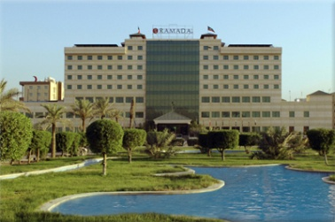
Hotel Copthorn Al-Jahra  Tel. +965 2459 0000 Fax. +965 2459 0005  E-mail: admin@cop-aljahra.com  Help Desk: 99479895 – 97517779 - 66742955 | 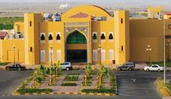
Continental - Farwaniya  Tel. +965 247 36700 Fax. +965 247 12793  Help Desk: 55244554 - 99894079 | 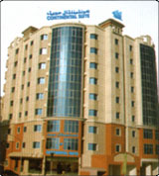
Kuwait Continental Hotel  Tel. +965 252 7300 Fax.+965 252 9373  Help Desk: 97564345 | 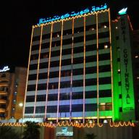

From Ranges to Hotels

Telephone Numbers of Embassies



الجمهورية الإندونيسية | +965 24839927 | 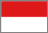 | The Republic of Indonesia
جمهورية أوزبكستان | +965 25376603 |  | The Republic of Uzbekistan
الجمهورية الإسلامية الإيرانية | +965 25350246 |  | The Islamic Republic of Iran
جمهورية باكستان الإسلامية | +965 25327649 |  | The Islamic Republic of Pakistan
جمهورية بنغلادش الشعبية | +965 25316042 |  | The People's Republic of Bangladesh
مملكة بوتان | +965 22516640 |  | The Kingdom of Bhutan
مملكة تايلند | +965 25317530 | 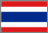 | The Kingdom of Thailand
جمهورية سيرلانكا | +965 25339140 |  | The Republic of Sri Lanka
جمهورية الصين الشعبية | +965 25333340 |  | The People's Republic of China
الفلبين | +965 25349099 |  | Philippines
جمهورية كوريا | +965 25351571 |  | The Republic of Korea
جمهورية كوريا الديمقراطية الشعبية | +965 25329462 | 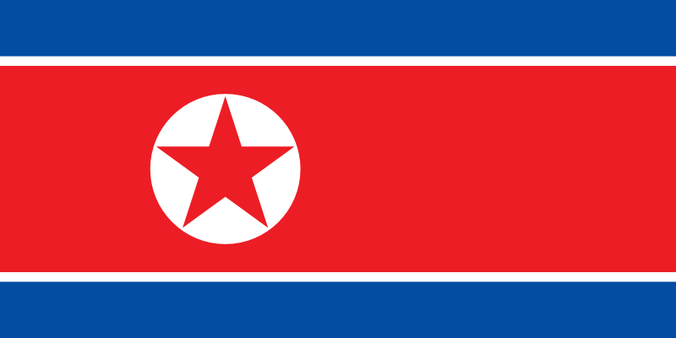 | The Democratic People's Republic of Korea
ماليزيا | +965 22550394 |  | Malaysia
منغوليا | +965 99674826 |  | Mongolia
ميانمار الإتحادية | +965 25240736 |  | The Federal Myanmar
جمهورية نيبال الفيدرالية | +965 67606442 |  | The Federal Republic of Nepal
جمهورية الهند | +965 22550379 |  | The Republic of India
اليابان | +965 25309400 |  | Japan

